Franklin COMP 294

Practicum Project Weekly Status Report

Name: Christa Fox

Course Number: COMP294-R1WW (F17)

Project Name: F17Gradebook

Week Number: 7

Progress for the week

Completed tickets 24, 29, 30, and 31 by Tuesday

Attended the presentation

* Ticket 24: Implement “on click” attributes for Attendance activity:
  + This links from the courses pages, and all that was needed is a back button, but it is already integrated into the design by clicking on the back arrow on the device.
* Ticket 29: Implement “on click” attributes for Calendar activity:
  + This links from the courses pages, and all that was needed is a back button, but it is already integrated into the design by clicking on the back arrow on the device.
* Ticket 30: Implement “on click” attributes for Contacts activity:
  + Linked Contacts from resources  
    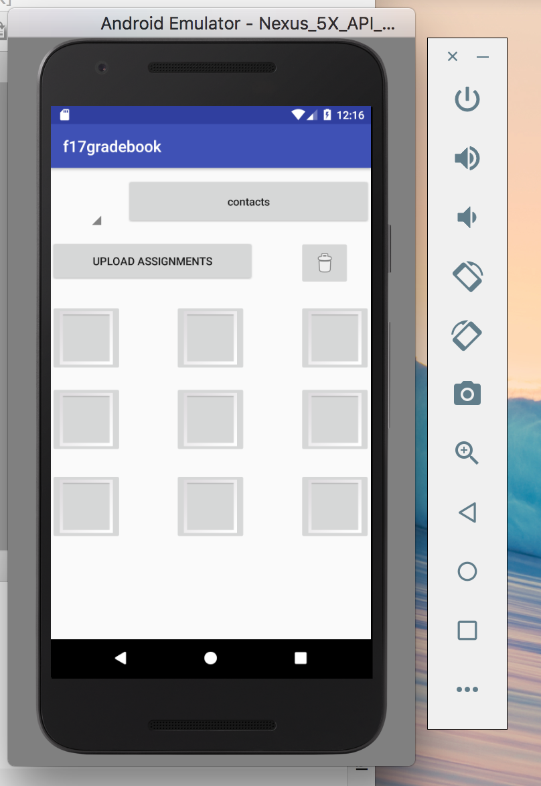  
    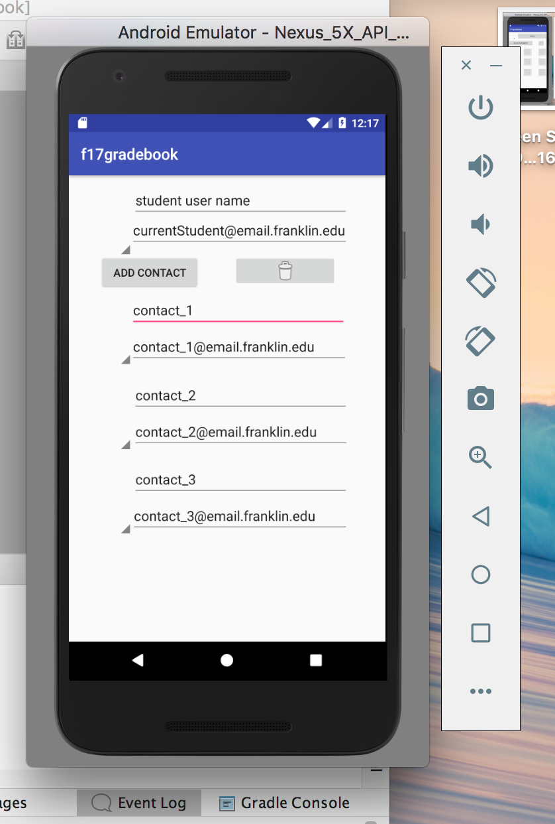
* Ticket 31: Implement “on click” attributes for Contacts activity:
  + Links from courses to resources using the tool icon  
    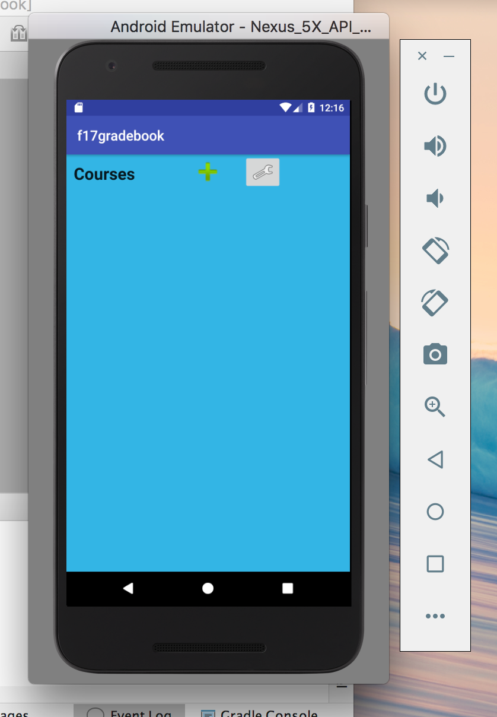

Problems Solved

* There were some issues with pushing and pulling that overwrote some of my code. These were resolved October 21.
* The XML I had written had initially defaulted to a constraint layout which is no longer an API that is available on the Android developer. I kept getting a class file missing and it w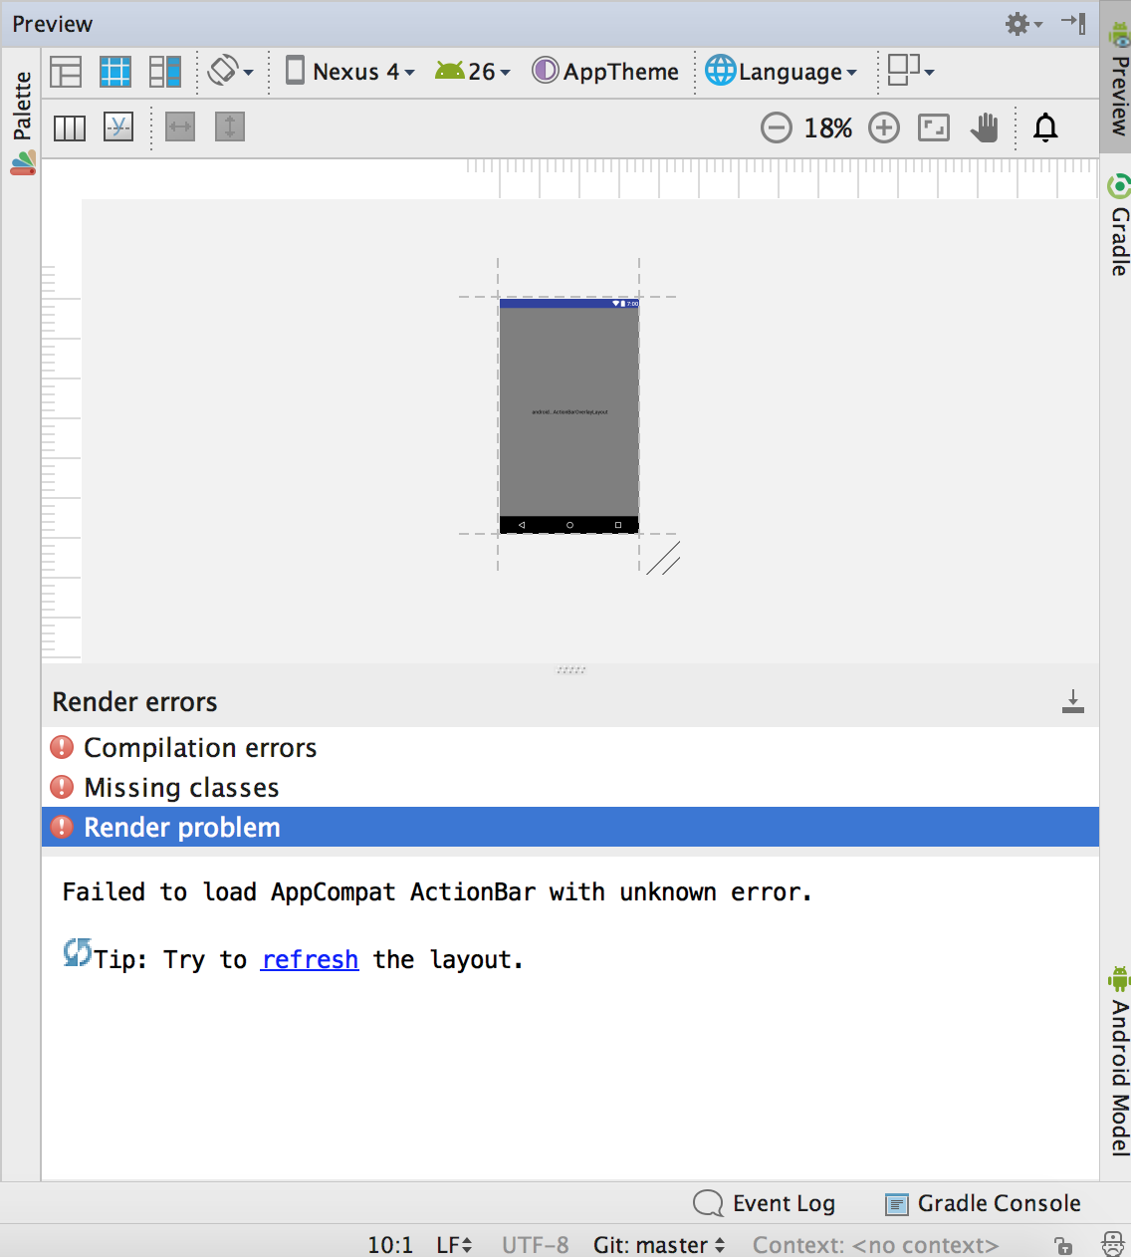as for this reason
* Emulator is up and running on my computer.
* Discussed new team member that was not able to attend the meeting. Will pass off my calendar application to him, and suggest he work on the stretch goals associated with it that I completed the research for.

Communication

* Unfuddle: accepted 4 tickets
* Completed 4 tickets
* Pulled from the repository
* Committed changes
* Used text/email/google hangouts
* Google hangout messages and meet October 21, 2017

Goals for next week

* Complete the Java Class Coding
  + Create helper activities as needed
* Working finished product that is ready to test
* Database functional and working with our class files
* Test the app as we create it and log these
* Log previous (from weekly status reports) and current testing in excel sheet on Unfuddle